The Attitude–Behaviour Gap in Tourist Environmental Engagement in Nainital

Urban Immersion Individual Submission:
Part 2 (Academic Paper)

Submitted By:
Aarushi Roy
(M2024bsass001)
BS Analytics and Sustainability Studies (2024–28),
Tata Institute of Social Sciences, Mumbai



Introduction and Problem Statement
Nainital, a colonial-era hill station in Uttarakhand's Kumaon region, is centred on the ecologically sensitive Naini Lake and is one of the most visited destinations in the Indian Himalayan Region. In recent years, the town's ecological base has come under measurable stress. Jain et al. (2024) documented microplastic pollution in the lake at surface concentrations of 8.6–56.0 particles per litre, rising to 88 particles per litre at hotspots, and sediment concentrations of 400–10,600 particles per kilogram. Sharma (2014) reported year-round exceedances of permissible limits for turbidity (smog), conductivity, alkalinity, and heavy metals, particularly at the more heavily trafficked Mallital end. Down To Earth (2018) further notes that Naini Lake has reached its zero level fifteen times since 2000, compared with only twice in the entire preceding century, and that the Sukhatal recharge zone, which contributes an estimated 40–50% of the lake's subsurface recharge, is being progressively encroached upon. In September 2024, the National Green Tribunal directed the state of Uttarakhand to classify Nainital district by carrying capacity and environmental sensitivity, triggering the state's first formal Tourist Carrying Capacity assessment in July 2025.
Against this backdrop, tourist behaviour is treated in both policy and popular discourse as a proximate driver of environmental stress, and the standard response has been to install signs, guidelines, and rules at tourist sites. Yet the empirical assumption that awareness translates directly into behaviour has been challenged in the environmental psychology and sustainable tourism literatures for over two decades (Blake, 1999; Kollmuss & Agyeman, 2002; Juvan & Dolnicar, 2014).
This paper, therefore, asks: How does tourist stated awareness of on-site environmental information relate to their pro-environmental behaviour during their visit to Nainital, and what does the gap between the two reveal about the sufficiency of current environmental infrastructure?
The question is answered using primary tourist survey data (n = 311) and a supplementary ten-site environmental infrastructure audit. The paper's specific objectives are: (1) to characterise tourists' stated environmental awareness; (2) to characterise their pro-environmental behaviour; (3) to examine the association between the two and quantify the observed gap; and (4) to assess whether infrastructure provision at tourist sites is aligned with the awareness and behaviour patterns observed.

Literature Review
2.1 The Attitude-Behaviour Gap
The starting point for this study is the well-established finding that pro-environmental knowledge and attitudes does not translate reliably into pro-environmental behaviour. Kollmuss and Agyeman (2002) have combined the elements of this literature in what they describe as the "gap" between knowledge and action, discussing linear-progression models, altruism models, and sociological models, and collecting both internal and external barriers that stand between "knowledge" and "action". The "information deficit" model, which assumes more information equals more action, had been previously challenged by Blake (1999), based on evidence from the UK, which identified three groups of barriers: individual, responsivity, and practicability. This fieldwork also observed that displaying information at tourist sites is a necessary but not sufficient condition for behaviour change.
2.2 The Gap in Tourism Specifically
Juvan and Dolnicar (2014) provide the foundational tourism-specific extension of this literature. In an ethnographic study of environmental activists on holiday, they found that even highly environmentally aware tourists displayed a marked attitude-behaviour gap and deployed six distinct justification strategies to reduce cognitive dissonance rather than change behaviour. Their central claim is that vacation behaviour is not driven by the same factors as home behaviour, and that high awareness routinely fails to produce sustainable behaviour in tourism contexts. Li et al. (2024) reviewed 331 publications on sustainable tourist behaviour and found that "the actions of tourists do not consistently align with their expressed attitudes and intentions." Carvajal-Trujillo, Pérez-Gálvez, and Orts-Cardador (2024), did a bibliometric analysis of 2,005 articles across two decades, also concluded that positive attitudes do not necessarily translate into responsible holiday choices.
2.3 Value-Belief-Norm and Theory of Planned Behaviour
Two theories are most frequently mentioned to account for the formation of this gap. There are two theories that have recurred most often to explain when and why the gap arises. For this research, the Theory of Planned Behaviour (Ajzen, 1991) states that behaviour is a function of intention. Attitude towards the behaviour and the subjective norms, along with Perceived Behavioural Control (PBC), influence this intention. However, PBC is also known to have direct effects on behaviour under conditions of imperfect control. The Value-Belief-Norm theory (Stern, 2000) builds on values and depictions of the ecological worldview, in terms of the New Ecological Paradigm, and identifies norms (awareness of the consequences) as pointing toward an assigned responsibility and a personal moral norm that leads to behaviour. Stern's key insight for the present study is that VBN predicts environmentally significant behaviour best when beliefs are matched to a specific behaviour. Predictive power also drops sharply when researchers try to link general environmental beliefs to broad behavioural composites. Han (2015) proposed a possible merger of both models in the tourism field. He demonstrated that both model factors are important in an eco-lodge context: personal norms, along with perceived behavioural control, explain environmental choices.
2.4 Information and Contextual Constraints
However, Steg and Vlek (2009) have argued that motivational factors alone are insufficient to explain pro-environmental behaviour. The physical infrastructure, the availability of the facilities, and enabling cues all facilitate or hinder motivating behaviour. They also note that overall, the relationship between environmental concerns and pro-environmental attitudes and behaviours is "generally not strong. A review of visitor-education programmes in protected areas by Marion and Reid (2007) revealed that overall, most visitor-education programmes changed one or more of three different variables (visitor knowledge, behaviour, or resource conditions) in a desired direction, and that most studies investigated knowledge rather than behaviour directly at the site. Similarly, Ballantyne, Packer and Falk (2011) concluded that on-site interpretation can change behaviour and that effects are unlikely to occur unless reinforced.
2.5 Himalayan Hill-Station and Nainital Context
Kuniyal (2005) measured the amount of solid waste generated by tourists along the Valley of Flowers–Hemkund Sahib circuit, thus quantifying the load on fragile ecosystems in Uttarakhand. According to a Mussoorie tourist survey (Sharma et al., 2022), 94.8% of tourists would prefer to use reusable alternatives to plastic, and 73% of the tourists said that they will be ready to pay more for the same; but, the problem with plastic-waste behaviour on the ground was still there. In a recent study, Kuniyal et al. (2025) defined daily limits for sustainable visitor numbers that were much lower than the actual numbers at the Char Dham sites, putting into context how over-tourism is observed in Nainital and situating it within a statewide emergency. The literature essentially lacks engagement with the ecological and hydrological aspects of Nainital (Jain et al., 2024; Sharma, 2014) and also with policy and grey literature on land-use encroachment, water depletion, and the NGT process in Nainital, in particular. No published study has quantitatively examined the attitude-behaviour link among tourists in Nainital, and that is the specific gap this paper addresses.
2.6 Sustainable Development Goals Framing
In 2017, the World Tourism Organisation and United Nations Development Programme (UNDP) correlated tourism with the 17 SDGs, focusing mainly on Goal 12 (responsible consumption and production). Following this, Dolnicar and co. (2023) further demanded empirically proven behaviour change interventions to shift the behaviour of tourists towards SDG 12-related behaviours. This paper also situates Nainital within that call and connects it with SDG 11 (sustainable cities and communities), as Nainital is a stressed urban town in the hill region, and with SDG 15 (life on land) due to the biodiversity value of the Kumaon region.

Theoretical Framing
This study has three nested levels. On the highest level, the value-action gap tradition of Blake (1999), Kollmuss & Agyeman (2002), and Juvan & Dolnicar (2014) provides the phenomenon of interest: Awareness does not lead to action, thus the empirical part is to characterise the gap and to look at what correlates with it. At the explanatory level, Value-Belief-Norm theory (Stern, 2000) is the primary lens because the empirical results (presented in Section 5) show that environmental awareness predicts a specific environment-adjacent behaviour (dustbin use) but does not predict outcomes theoretically unrelated to environmental cognition (local purchasing, overall satisfaction, general cleanliness perception, broader responsible tourism). This specificity pattern is a signature prediction of VBN.

Methodology
4.1 Study Design
The study uses a cross-sectional, mixed-methods design combining a tourist survey (Tourist Data) with an on-site environmental infrastructure audit (Location Data).
4.2 Sampling and Sample Description
Tourist respondents have been surveyed at Naini Lake and in nearby high-tourist areas. Prior to administration, consent has been obtained on-record with the tourists. 320 responses were received; 311 were used, and the remainder (1 non-consent and 8 blanks) were dropped. The last sample consisted of 62% male, 37% female and less than 1% other gender. 58% of the sample were first-time visitors. 57% of the respondents were domestic travellers, with the highest numbers coming from Uttar Pradesh (36%), followed by Delhi (19%), Uttarakhand (6%) and 3% from overseas. Leisure/Vacation (52%) and Family Trip (33%) were the major reasons for visits, while Pilgrimage, Honeymoon, Adventure, and Business+Leisure each accounted for 13% of visits. The median duration was 1-2 days. Ten sites were surveyed and selected for infrastructure audit because they were considered to be representative of the lake boundary, commercial and viewing areas.
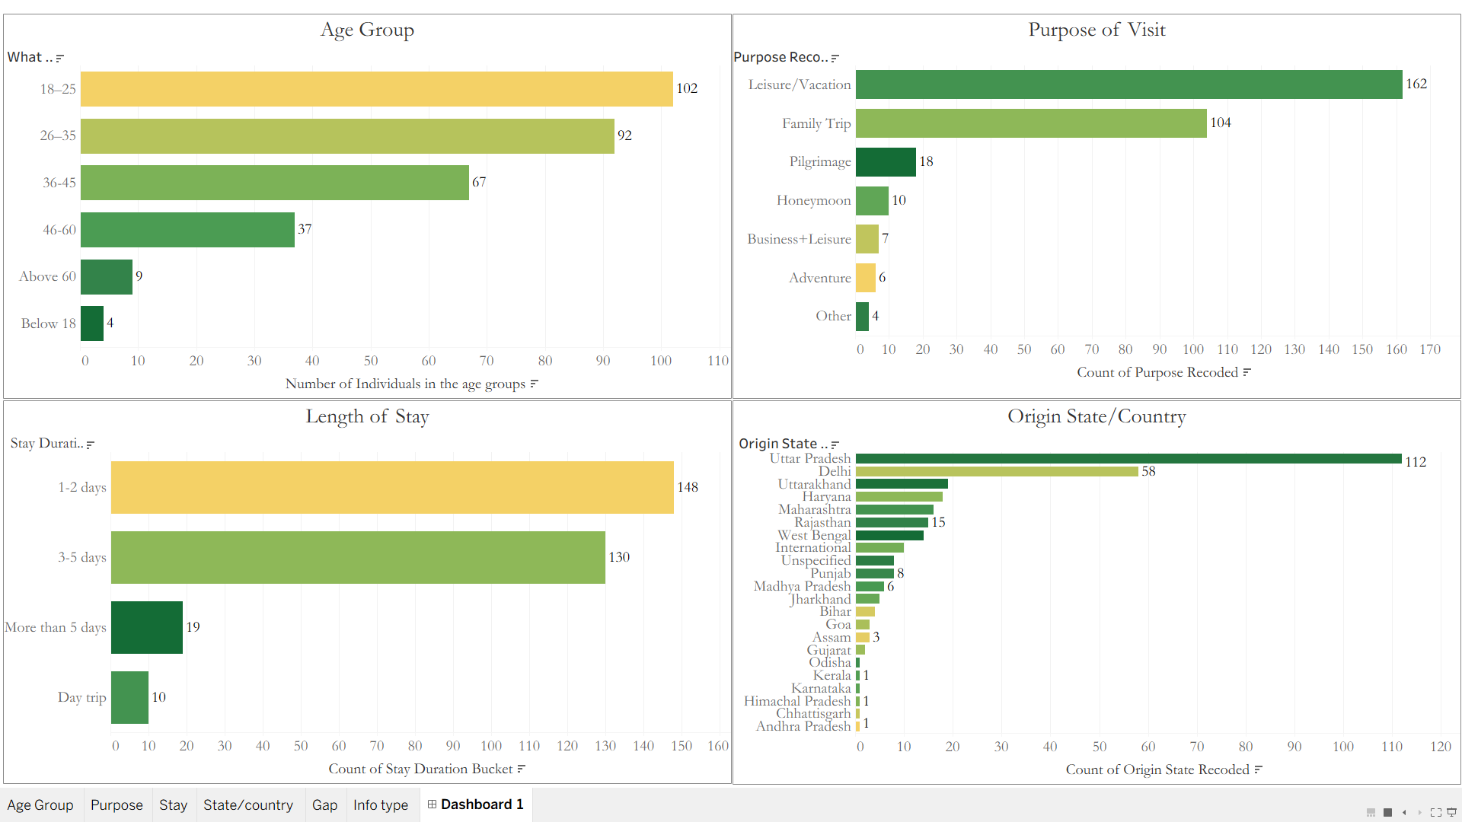
Figure. 1

4.3 Data Cleaning and Variable Construction
Data cleaning was performed in Python and executed sequentially for documentation. Version split columns were consolidated if the two versions had structurally equivalent columns or retained if structurally different, such as the amenity-use item in one version vs. the same item in the other but with a binary column. A clearly implausible value, in this example, a 10,000-night stay was not imputed but was left at a "missing" value. To reconcile the results of three different question formats used across the different versions of the questionnaire, length of stay was collapsed into four categories: day trip, 1-2 days, 3-5 days, and>5 days. Entries related to expenditures were forced into a five banded system. Key variables in the study were created as outlined below.
Primary awareness was considered in its binary form (seen/not seen) for the tourist concerning the presence of the environmental guidelines, specifically. As only one information item is environmental (environmental guidelines), it was identified as a control item; a general information awareness score was compiled by aggregating across all items except the content item, which is not a primary construct. The dustbin-use behavioural item was adopted to represent primary pro-environment behaviour (binary).
A second, more general Responsible Tourism Behaviour Score (0-3) was developed as the sum of the three sub-scores (dustbin use, purchase of local products, and local guide) and tested for discriminant validity. Free-text responses to the question on state of origin were recoded into State response types, with cities incorporated into their State, and small "Other" and "International" categories retained. A hierarchy of "specificity" was used to collapse multiple selections of purpose-of-visit, where the most specific category found in the answer was the most specific category to which to collapse. Two additive scores of infrastructure were built using location audit variables. The sum of the presence of environmental guidelines, rules and regulations, dustbin functional status, dustbin segregation and public toilet presence yielded an Environmental Infrastructure Score (0–5). A General Urban Infrastructure Score (0-6) was calculated, which added together the scores for three elements (footpath, disability access, directional signage presence, multilingual signage presence, parking availability, and emergency contact display). Other features that score 1 on all sites, e.g., on-site WiFi and healthcare, did not count toward the scoring but are included in this descriptive report as features.
4.4 Analytical Approach
Descriptive statistics for the sample and the distribution of the awareness, behaviour, and infrastructure variables were used to understand the sample under study. The key test of the awareness–behaviour relationship was a Pearson chi-square test of independence; the phi coefficient is a measure of the effect size, with Fisher's Exact test and continuity-corrected chi-square also reported. Robustness checks included chi-square tests (with a multilevel ordinal predictor, the general information awareness score) and independent-samples t-tests for continuous measures. A Spearman rank-order correlation matrix was generated for variables with an ordinal scale of measurement. The audit-versus-survey comparison was conducted at the aggregate (destination) level because the survey could not identify the individual site where each tourist stood; therefore, the two data sources could not be matched at the record level. Data analysis was carried out in IBM SPSS Statistics, and the visualisations were created using Tableau. Results were considered statistically significant at α = .05 and, according to the magnitude of the phi coefficient (Cohen, 1988), were deemed small (.10), medium (.30), or large (.50).
4.5 Ethical Considerations and Limitations
Information consent was recorded, and respondents who refused to give information were not included in the analysis. Responses were anonymous. Both instruments include the above-mentioned two-form version of the question, resulting in the item-level missingness rate of 31% for the awareness item and 22% for the behaviour item. Also, the audit sample size is relatively small (only 10 sites) for descriptive triangulation, but not for statistical inference at the site level. There is some social desirability bias, and observed behaviour would yield much higher figures, as the reported 74% dustbin-use rate below was overreported.

Analysis
5.1 Awareness Distribution
Of the 244 tourists who answered the awareness item, 139 (57.0%) reported noticing environmental guidelines at tourist sites, and 105 (43.0%) reported not noticing them. The most-noticed on-site items were entry fees and timings (82.4%), followed by environmental guidelines (57.0%), local rules and regulations (52.9%), and emergency contact information (42.2%). Fewer than 2% of respondents reported noticing none of these items. On the general information awareness score, the modal category was two of four items noticed (37.3% of respondents who answered the item).
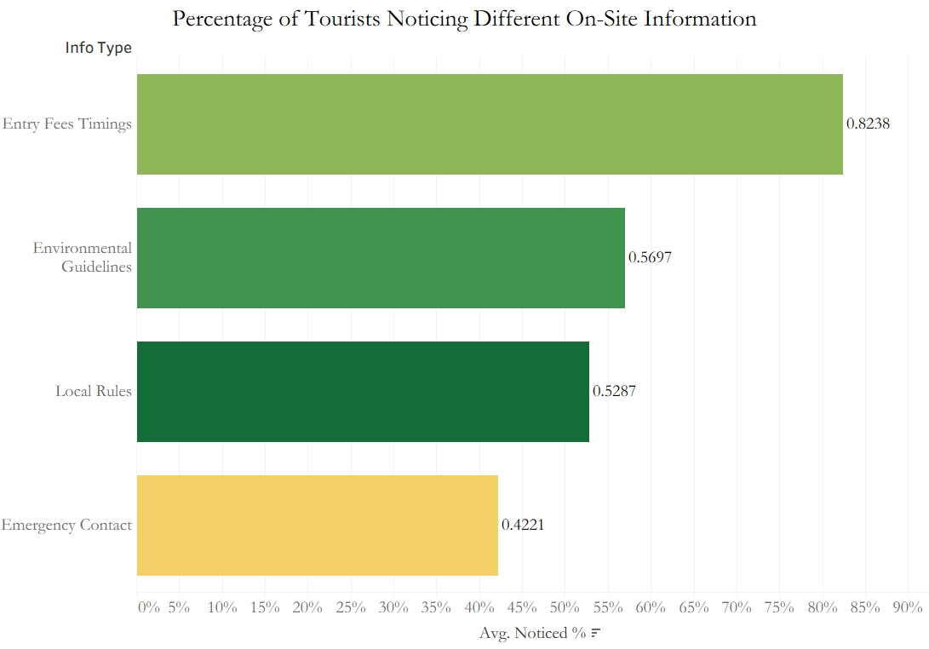
Figure. 2

5.2 Behaviour Distribution
Of the 215 tourists who answered the specific amenity-use questions, 159 (74.0%) reported using dustbins during their visit. Bench and seating use was similarly high (87.9%), while public toilet use (44.7%) and drinking-water station use (17.2%) were lower. Regarding broader responsible tourism items, 36.6% of respondents reported purchasing local products, handicrafts, or souvenirs during the trip, and 11.0% reported hiring a local guide. The distribution of the composite Responsible Tourism Behaviour Score was concentrated at 0 and 1 (together 68% of respondents who answered all three items).
5.3 The Core Awareness–Behaviour Test
The core cross-tabulation tests whether tourists who reported noticing environmental guidelines were also more likely to report using dustbins. Among the 173 respondents with valid data on both variables, 80.4% of aware tourists reported using dustbins, compared with 68.4% of unaware tourists — a descriptive gap of 12.0 percentage points in the theoretically expected direction. The Pearson chi-square test returned χ²(1) = 3.28, p = .07, with phi = .14. Fisher's Exact returned a two-tailed p of .08, and the continuity-corrected chi-square returned p = .10. The relationship therefore does not clear the conventional α = .05 threshold, but is a small, directional, marginally significant association

Table 1
Cross-Tabulation of Environmental Awareness and Pro-Environmental Behaviour (n = 173)
Noticed Environmental Guidelines |  | Dustbin Use |  | Total
 |  | No | Yes
No | Count | 24 | 52 | 76
 | % within row | 31.6% | 68.4% | 100.0%
Yes | Count | 19 | 78 | 97
 | % within row | 19.6% | 80.4% | 100.0%
Total | Count | 43 | 130 | 173
 | % within row | 24.9% | 75.1% | 100.0%
Note. Pearson χ²(1) = 3.28, p = .07; continuity-corrected χ² = 2.67, p = .10; Fisher's Exact (2-tailed) p = .08; φ = .14. Marginally significant, directionally consistent.
Firstly, 74% of tourists in the sample had already reported using dustbins; this ceiling effect means that when the outcome variable is highly saturated, less variance is available for the other variable(s) to account for. Therefore, it is common to find small effect sizes, and they do not indicate that there is no true effect. Second, and more importantly, the observed result is in line with the literature, because the theoretical model the research was based on makes a clear prediction: awareness –behaviour relationships, in the tourism context, would be only modest and inconsistent (Juvan & Dolnicar, 2014; Steg & Vlek, 2009).
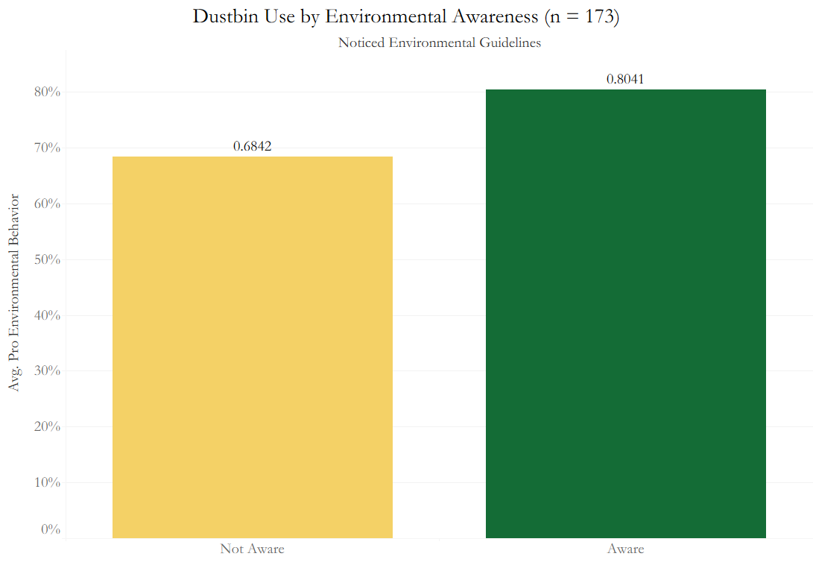
Figure. 3
5.4 Robustness and Discriminant Checks
Three additional analyses were conducted to characterise the nature of the awareness-behaviour link further. First, the general information awareness score (0–4 items noticed) was cross-tabulated against dustbin use. Dustbin-use rates rose monotonically with awareness score, such as 64.7%, 76.6%, 76.8%, and 84.2% at scores of 1, 2, 3, and 4, respectively. However, the overall Pearson chi-square was not significant, χ²(3) = 2.97, p = .40. The Linear-by-Linear Association test, which is the appropriate test for an ordinal predictor against a binary outcome, returned 2.30, p = .13, again marginal but consistent with the monotonic pattern.
Second, awareness was cross-tabulated with the purchase of local products — a behaviour theoretically unrelated to on-site environmental information. The result was a complete null: 40.6% of unaware tourists and 38.5% of aware tourists reported purchasing local products, with phi = –.03, p = .70. Third, independent-samples t-tests compared aware versus unaware tourists on three continuous outcomes: overall satisfaction (M aware = 3.74, M unaware = 3.84, p = .35), cleanliness rating (M aware = 3.50, M unaware = 3.38, p = .33), and the Responsible Tourism Behaviour Score (M aware = 1.06, M unaware = 0.98, p = .42). All three returned no significant difference.
Taken together, this pattern is theoretically informative. Environmental awareness is weakly and marginally associated with a specifically environment-adjacent behaviour (dustbin use). However, it shows no association with either a general satisfaction rating, a general cleanliness perception, or unrelated tourism behaviours. This discriminant pattern rules out a simple confounding explanation in which "conscientious tourists" would look aware and behave well across all measures.
Table 2
Robustness and Discriminant Check Summary
Test | n | Statistic | df | p | Effect Size
General Info Awareness Score × Dustbin Use | 215 | χ² = 2.97 | 3 | .40 | φ = .12
Awareness × Purchased Local Products | 240 | χ² = 0.15 | 1 | .70 | φ = –.03
Awareness × Overall Satisfaction (t-test) | 178 | t = 0.95 | 176 | .35 | M diff = 0.10
Awareness × Cleanliness Rating (t-test) | 178 | t = –0.98 | 176 | .33 | M diff = –0.12
Awareness × Responsible Tourism Score (t-test) | 244 | t = –0.81 | 242 | .42 | M diff = –0.08
Note. All tests are two-tailed. All p > .05. Discriminant pattern: environmental awareness relates only to the environment-adjacent behaviour (dustbin use, reported in Table 1), not to unrelated tourism behaviours or general perceptions.
5.5 Correlational Structure
Spearman's correlation matrix of the ordinal and rating variables revealed one noteworthy association beyond those already reported: general information awareness was positively correlated with tourists' ease-of-navigation rating (ρ = .17, p = .01, n = 244). This indicates that people who perceived a greater amount of in-place information were also the ones who reported greater ease of navigation, which is in line with a general attentiveness or engagement effect and should be treated as a covariate in new studies, but does not detract from the above specificity result.
5.6 Site-Level Environmental Infrastructure
The Environmental Infrastructure Score showed a range from 2 to 5 on the 10 sites shown for which this information was available, with a mean score of 2.6 and a median score of 2. The scores for the remaining sites were as follows: 5 sites scored 5, 2 sites scored 4, 2 sites scored 3, and 5 sites scored 2. Among the items at the individual site, 60% had environmental information guidelines, 90% had rules and regulations, 30% had emergency contact information, 100% had dustbins on hand, and 40% had working dustbins. In comparison, 30% had fully segregated (dry/wet) bins. At 40% of sites, public toilets existed. The mode score of the General Urban Infrastructure Score was also grouped, accounting for 3 scores at 1 site and 5 scores at 2 sites. All sites lacked public Wi-Fi/on-site health facilities.
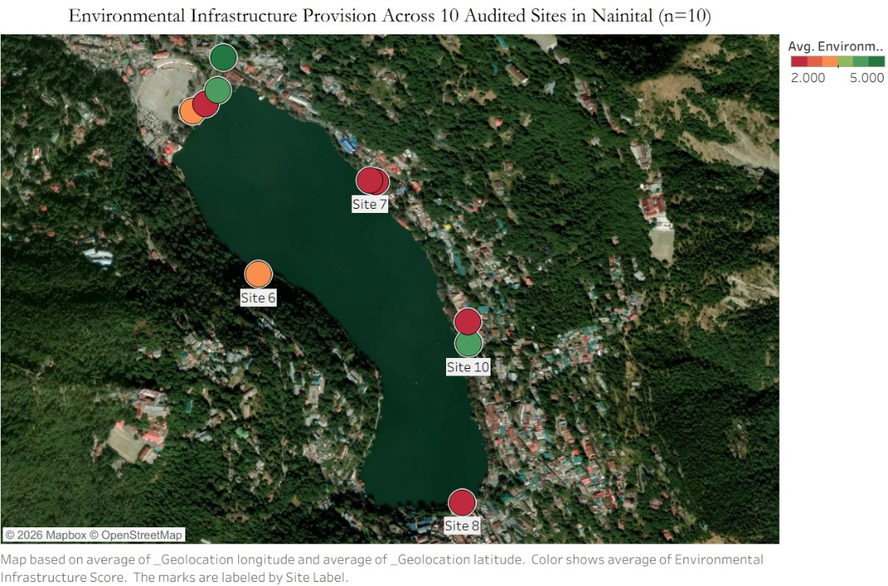
Figure. 4
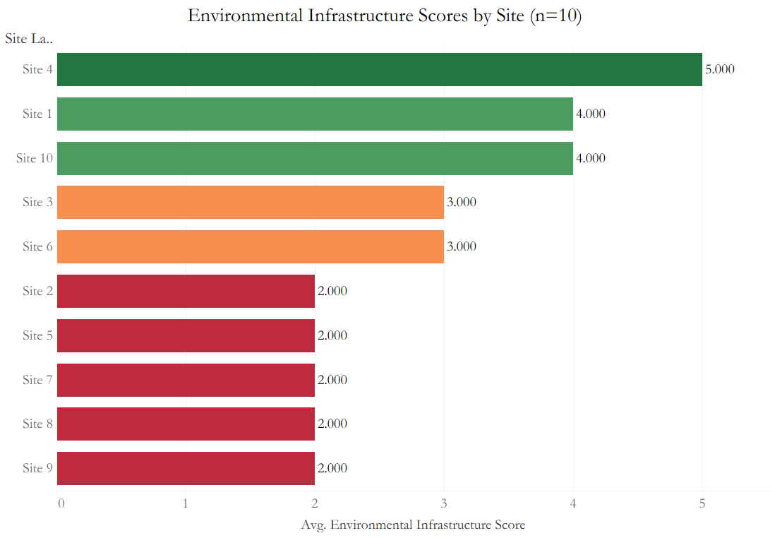
Figure. 5

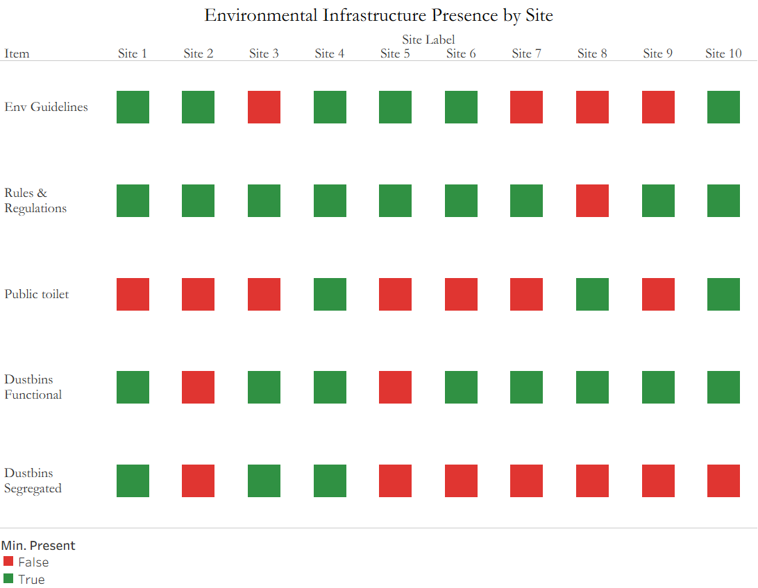
Figure. 6
5.7 Aggregate Supply-Versus-Demand Comparison
The final analysis compares the aggregate site-level provision of each information type with the proportion of tourists who report noticing it. Environmental guidelines were displayed at 60% of sites and noticed by 57% of tourists. Emergency contact information was displayed at 30% of sites and noticed by 42% of tourists. The striking result is for local rules and regulations: displayed at 90% of sites and noticed by only 53% of tourists.
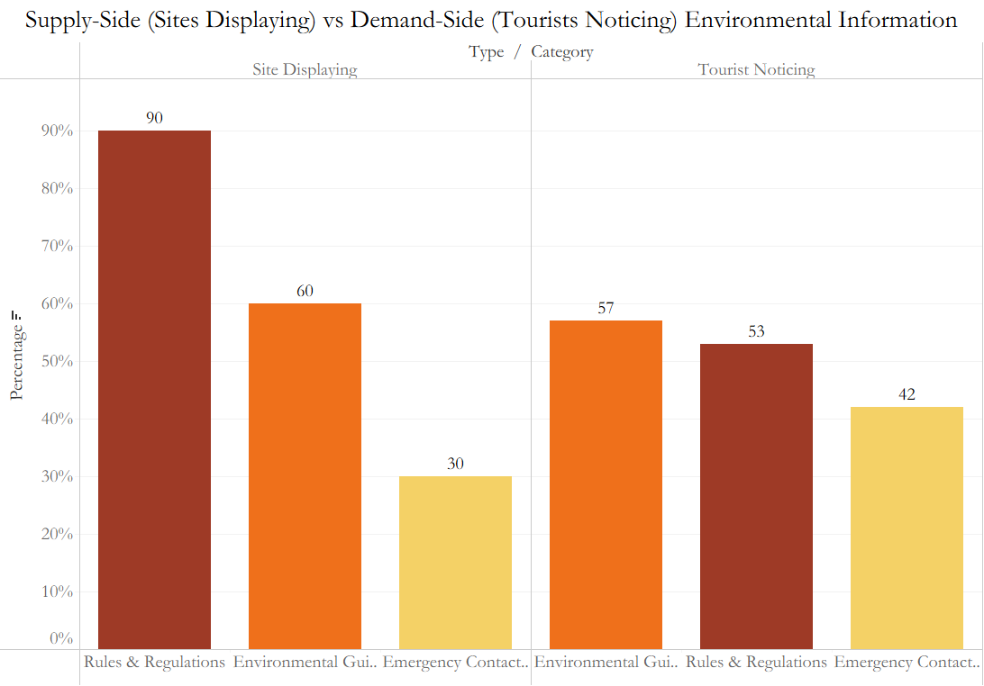
Figure. 7

Discussion
The overall picture of the empirical results of this study is not one of a strong link between awareness and behaviour; it is not one of an absolute null. It is a snapshot of a certain, small, and, at least in theory, clear pattern: environmental knowledge is a poor predictor of a specifically environment-adjacent behaviour, and a poor indicator of any other tourism behaviour, that is, except for environmental infrastructure that is widely available at tourist sites in Nainital, with the largest single mismatch not being in the provision but in salience. For each of these findings, there is a theoretical claim. The most interesting result of this paper is the specificity of the awareness effect. If the dispositional or “conscientious tourist” model were accurate, one would expect there to be a relationship between environmentally related attitudes and the majority of pro-social tourist behaviours, such as making more purchases of local products, giving the tourist rating a score for the cleanness of the meals eaten, and expressing higher overall satisfaction with the tourist experience. This is not what the data indicate. Knowing about awareness predicts only the awareness target behaviour (dustbin usage), which was expected by a Value-Belief-Norm hierarchy after matching beliefs to the target behaviour (Stern, 2000). This is the best argument the study can offer for a reading consistent with the VBN, and this discriminant validity design is not usually applied in tourism behaviour studies, where most constructs in such fields are measured with composite scales.
The primary result is small and insignificant, but there are three considerations. The ceiling effect is one place to begin: 74% of tourists already use a dustcover when travelling, which reduces the design's potential to reveal variance-explaining effects, and small phi coefficients are the result. Second, the phi values observed by Steg and Vlek (2009) in the pro-environmental behaviour literature are generally low; for example, .14 is well within the ordinary range. Third, even when travelling, tourists are very environmentally conscious, yet Juvan and Dolnicar (2014) show that they often employ cognitive mechanisms that allow them to justify inaction during vacation, specifically including "vacation as exception" framing, deindividuation, and moral licensing.
This supply/demand triangulation tips over the "tourist psychology" lens for destination infrastructure designing. What is not clearly understood is why “rules and regulations” were found at 90% of the sites visited, while only 53% of the tourists noted them, given that there is no information-supply deficit. Owned by Ajzen (1991) and further detailed by Steg and Vlek (2009), it can be seen as a salience and PBC (perceived behavioural control) issue. Similarly, in a review of visitor education programmes, Marion and Reid (2007) found that they actually promote on-site information not so much through the number of signs left behind, but through attentiveness. The situation looks similar in Nainital: A large proportion of tourists already indicate the desired behaviour, and salience, i.e. making things more noticeable to visitors to the site, is probably the easier of the two margins to deploy, not the installation of more signs.
Four implications come to the fore for Nainital's touristic and municipal activities. First, the important infrastructure investment is probably not an increase in environmental signage, but rather the redesign of existing rules-and-regulations displays for more natural attention points (entry gates, viewpoint plateaus, boat launches), better typographic contrast (larger and more eye-grabbing), and pictorial rather than text-heavy formats. Second, the use of functional dustbins and segregated dustbins (completely dry and wet) is inappropriate: Only 40% of all sites have functional dustbins, and only 30% of sites have well-segregated dry/wet dustbins. Dustbin condition and segregation line up as a high-leverage, low-cost target, as dustbin usage is the main environmental behaviour tourists engage in. Lastly, emergency contacts appear at just 30% of sites; therefore, this is one to investigate: whether tourists are inferring this information from other ambient cues, such as the presence of police and signs from other agencies that could be codified. Fourth, the audit-versus-survey approach adopted here would be easily replicated at the scale at which NLRSADA and Uttarakhand Tourism should be working, as part of the ongoing carrying-capacity assessment process. Three limitations should temper these interpretations. Three limitations temper these interpretations. The sample of 173 students used for the core test in the listwise-deleted sample is small and has low power; the results are strengthened or complicated by a larger replication. No record-level information is available to connect tourist comments with individual sites, and the ten-site audit does not allow for statistical inference at the site level; rather, it enables justification for an aggregate comparison, which cannot answer causal questions about site conditions and individual behaviour. We do not know how prevalent this discrepancy is for self-reported behaviour, and in the context of dustbin use, socially desirable behaviour is likely to be over-reported.

Conclusion
This paper aimed to explain the correlation between respondents' declared environmental awareness and their pro-environmental practices in Nainital city, and to understand the provision of environmental infrastructure on the ground. The information compiled from a KoboToolbox survey of 311 tourists and an infrastructure audit of 10 sites suggests three key findings. First, there is only a weak, marginally significant association between environmental awareness and a behaviour linked to the environment itself (dustbin use). However, no such association is observed for the other tourism behaviours and general satisfaction. This pattern is theoretical in its specificity and should be interpreted in light of the concept of 'Value-Belief-Norm'. Second, the size of the primary effect of awareness on behaviour is small, not significantly different from zero, as is typical of a large literature of small and inconsistent awareness-behaviour associations in the tourism field, and is also limited by a ceiling effect on the outcome variable. Thirdly, the most conspicuous lack of the study is not the differences between tourists' knowledge and behaviour, but the differences between what is shown at sites and what tourists perceive.
In the context of Nainital's environmental governance, the practical implication is that the additional returns from installing more environmental signage will be small; the returns will come from the more powerful interventions, namely, salience redesign of existing signage, improved dustbin conditions, and segregation. The formal incorporation of the audit-survey triangulation approach into the state's ongoing Tourist Carrying Capacity process will likely be larger. The paper offers the first quantitative test of the attitude-behaviour gap in the documented research literature in an Indian Himalayan hill resort. It demonstrates the utility of a discriminant validity design in establishing the credibility of otherwise limited awareness-behaviour results. Future research efforts should replicate with a larger sample, examine the link between tourist response and record-level (rather than the most salient) members of the diversionary menu, and test the effectiveness of the interventions recommended in this paper in altering tourist behaviour in a field setting.

References
Ajzen, I. (1991). The theory of planned behavior. Organizational Behavior and Human Decision Processes, 50(2), 179–211. https://doi.org/10.1016/0749-5978(91)90020-T
Ballantyne, R., Packer, J., & Falk, J. (2011). Visitors' learning for environmental sustainability: Testing short- and long-term impacts of wildlife tourism experiences using structural equation modelling. Tourism Management, 32(6), 1243–1252. https://doi.org/10.1016/j.tourman.2010.11.003
Blake, J. (1999). Overcoming the "value-action gap" in environmental policy: Tensions between national policy and local experience. Local Environment, 4(3), 257–278. https://doi.org/10.1080/13549839908725599
Carvajal-Trujillo, E., Pérez-Gálvez, J. C., & Orts-Cardador, J. J. (2024). Exploring tourists' pro-environmental behavior: A bibliometric analysis over two decades (1999–2023). Journal of Tourism Futures. Advance online publication. https://doi.org/10.1108/JTF-02-2024-0033
Cohen, J. (1988). Statistical power analysis for the behavioral sciences (2nd ed.). Lawrence Erlbaum.
Dolnicar, S., Juvan, E., & Grün, B. (2023). Tourist behaviour change for sustainable consumption: Tourism Agenda 2030 perspective article. Tourism Review, 78(2), 358–367. https://doi.org/10.1108/TR-11-2022-0563
Down To Earth. (2018, September 15). Naini lake is depleting, but can we undo the wrongs? https://www.downtoearth.org.in/coverage/water/revival-of-naini-lake-needs-prompt-action-but-ownership-not-clearly-defined-57979
Han, H. (2015). Travelers' pro-environmental behavior in a green lodging context: Converging value-belief-norm theory and the theory of planned behavior. Tourism Management, 47, 164–177. https://doi.org/10.1016/j.tourman.2014.09.014
Jain, Y., Govindasamy, H., Kaur, G., Ajith, N., Ramasamy, K., Robin, R. S., & Ramachandran, P. (2024). Microplastic pollution in high-altitude Nainital lake, Uttarakhand, India. Environmental Pollution, 346, 123598. https://doi.org/10.1016/j.envpol.2024.123598
Juvan, E., & Dolnicar, S. (2014). The attitude–behaviour gap in sustainable tourism. Annals of Tourism Research, 48, 76–95. https://doi.org/10.1016/j.annals.2014.05.012
Kollmuss, A., & Agyeman, J. (2002). Mind the gap: Why do people act environmentally and what are the barriers to pro-environmental behavior? Environmental Education Research, 8(3), 239–260. https://doi.org/10.1080/13504620220145401
Kuniyal, J. C. (2005). Solid waste management in the Indian Himalayan tourists' treks: A case study in and around the Valley of Flowers and Hemkund Sahib. Waste Management, 25(10), 1029–1039. https://doi.org/10.1016/S0956-053X(03)00027-8
Kuniyal, J. C., Kanwar, N., Bhoj, A. S., Rautela, K. S., & Joshi, R. (2025). Carrying capacity and strategic planning for sustainable tourism practices in the Char Dham from the Western Himalaya, India. Scientific Reports, 15, 33478. https://doi.org/10.1038/s41598-025-20166-8
Li, C.-H., Wang, S., Zhao, X., & Xu, F. (2024). Sustainable tourist behavior: A systematic literature review and research agenda. Sustainable Development, 32(4), 3320–3341. https://doi.org/10.1002/sd.2859
Marion, J. L., & Reid, S. E. (2007). Minimising visitor impacts to protected areas: The efficacy of low impact education programmes. Journal of Sustainable Tourism, 15(1), 5–27. https://doi.org/10.2167/jost593.0
National Green Tribunal. (2024, September). Original application on Nainital carrying capacity and environmental sensitivity classification. Government of India.
Sharma, R., Rani, P., & Kaushik, P. (2022). Investigating the role of tourists and impact of knowledge, behaviour, and attitude towards plastic waste generation. Circular Economy and Sustainability, 3, 1–19. https://doi.org/10.1007/s43615-022-00216-3
Sharma, V. (2014). Water quality assessment of the central Himalayan lake, Nainital. Journal of Chemistry, 2014, Article 473074. https://doi.org/10.1155/2014/473074
Steg, L., & Vlek, C. (2009). Encouraging pro-environmental behaviour: An integrative review and research agenda. Journal of Environmental Psychology, 29(3), 309–317. https://doi.org/10.1016/j.jenvp.2008.10.004
Stern, P. C. (2000). Toward a coherent theory of environmentally significant behavior. Journal of Social Issues, 56(3), 407–424. https://doi.org/10.1111/0022-4537.00175
World Tourism Organization & United Nations Development Programme. (2017). Tourism and the Sustainable Development Goals — Journey to 2030. UNWTO. https://doi.org/10.18111/9789284419401

